The World Can Make More Water from the Sea, but at What Cost?
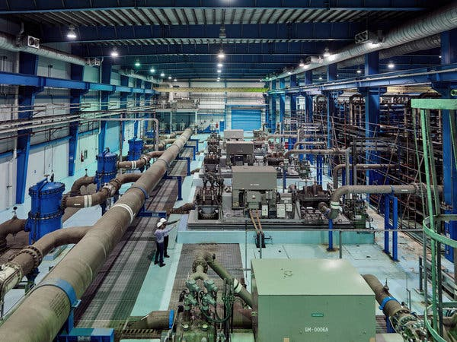
By Henry Fountain with photographs by Jamie McGregor Smith/October 25, 2019 New York Times
THUWAL, Saudi Arabia — Desalinated seawater is the lifeblood of Saudi Arabia, nowhere more so than at King Abdullah University of Science and Technology, an international research center that rose from the dry, empty desert a decade ago.
Produced from water from the adjacent Red Sea that is forced through salt-separating membranes, it is piped into the campus’s gleaming lab buildings and the shops, restaurants and cookie-cutter homes of the surrounding planned neighborhoods. It irrigates the palm trees that line the immaculate streets and the grass field at the 5,000-seat sports stadium. Even the community swimming pools are filled with hundreds of thousands of gallons of it.
Desalination provides all of the university’s fresh water, nearly five million gallons a day. But that amount is just a tiny fraction of Saudi Arabia’s total production. Beyond the walls and security checkpoints of the university, desalinated water makes up about half of the fresh water supply in this nation of 33 million people, one of the most water-starved on Earth.
Worldwide, desalination is increasingly seen as one possible answer to problems of water quantity and quality that will worsen with global population growth and the extreme heat and prolonged drought linked to climate change.
“It is a partial solution to water scarcity,” said Manzoor Qadir, an environmental scientist with the Water and Human Development Program of United Nations University. “This industry is going to grow. In the next five to 10 years, you’ll see more and more desalination plants.”
Saudi Arabia and other countries in the Middle East and North Africa are at the center of this growth, with large new desalination projects planned or being built. Renewable water supplies in most of these countries already fall well below the United Nations definition of absolute water scarcity, which is about 350 gallons per person per day, and a 2017 report from the World Bank suggests that climate change will be the biggest factor increasing the pressure on water supplies in the future.
Yet the question remains where else desalination will grow. “In low income countries, almost nothing is happening,” Dr. Qadir said. The primary reason is cost. Desalination remains expensive, as it requires enormous amounts of energy. To make it more affordable and accessible, researchers around the world are studying how to improve desalination processes, devising more effective and durable membranes, for example, to produce more water per unit of energy, and better ways to deal with the highly concentrated brine that remains.
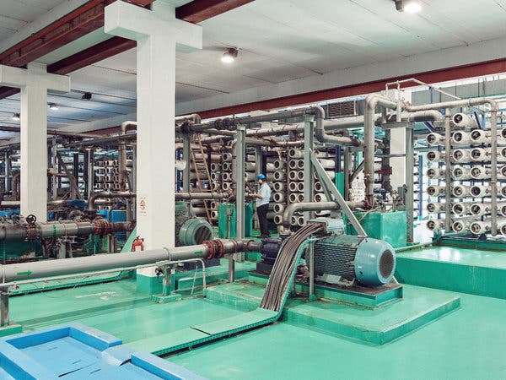
Electric water pressure pumps and reverse-osmosis membrane tubes at the Sawaco Desalination Plant in Jeddah, Saudi Arabia.
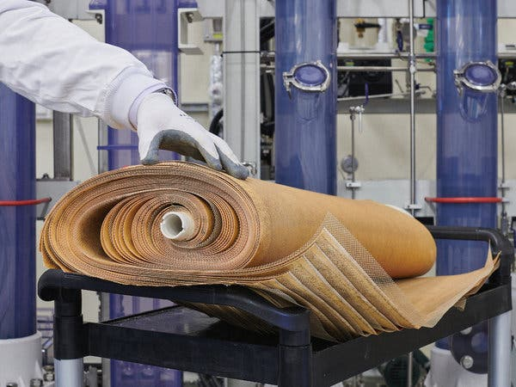
A sheaf of reverse-osmosis membranes, unfurled to show the layers that separate salt from water. Credit: Jamie Smith for The New York Times

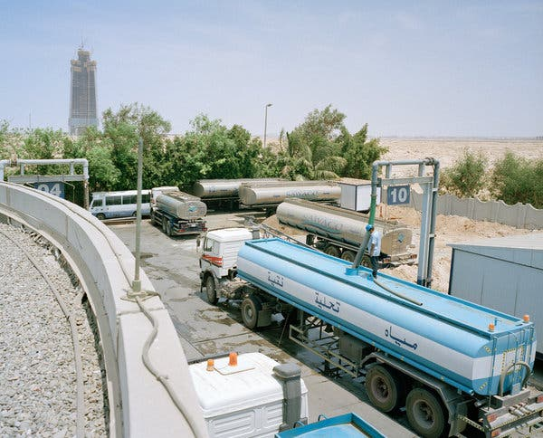
There are no water distribution pipes in this part of Jeddah - the desalinated water is distributed by truck.
Currently, desalination is largely limited to more affluent countries, especially those with ample fossil fuels and access to seawater (although brackish water inland can be desalinated, too). In addition to the Middle East and North Africa, desalination has made inroads in water-stressed parts of the United States (California), and other countries including Spain, Australia and China.
There are environmental costs to desalination as well: in the emissions of greenhouse gases from the large amount of energy used to run the desalting system and in the disposal of the brine, which in addition to being extremely salty is laced with toxic treatment chemicals.
Despite a practically limitless supply of seawater, desalinated water still accounts for about 1 percent of the world’s fresh water. Even in Saudi Arabia, where vast oil reserves (and the wealth that comes from them) have made the country the world’s desalination leader, responsible for about one-fifth of global production, there is a realization that the process must be made more affordable and sustainable. At the university here, engineers are aiming to do just that.
“We are trying to develop new processes, to consume less energy and be more environmentally friendly,” said Noreddine Ghaffour, a researcher in the Water Desalination and Reuse Center at the university, which is universally known as Kaust. As the center’s name implies, there is also a realization that treating and reusing wastewater can help decrease stress on water supplies. “Any place you are doing desalination you should also be doing water reuse,” said Paul Buijs, who serves as the contact between researchers and industry at the center.
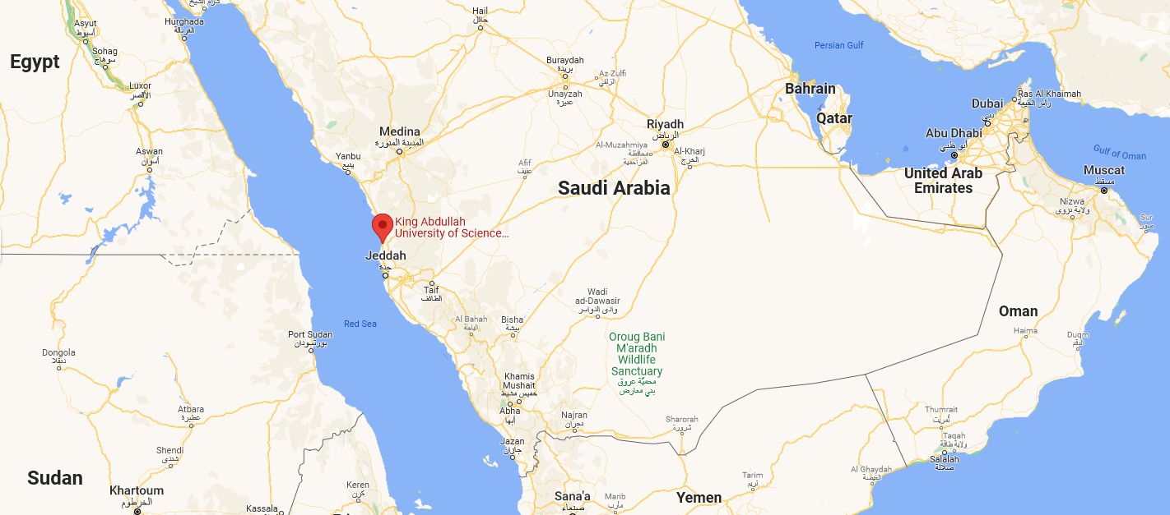
Kaust’s golf course, the only greenery not irrigated with desalinated water. Instead, the grass is maintained using treated wastewater.

Grass at the Kaust athletic stadium. The sprinklers use desalinated water.

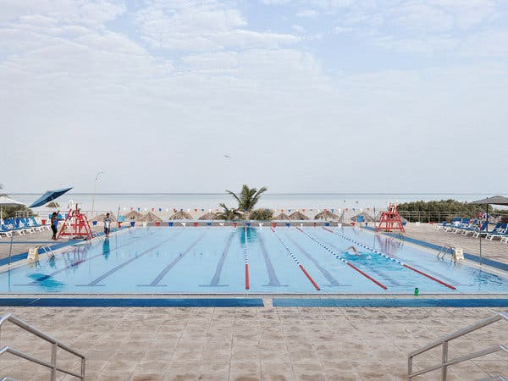
A community swimming pool adjacent to the Red Sea.
Outside the main Kaust desalination plant, which uses a technology called reverse osmosis, four huge tanks full of sand filter impurities from the seawater as it arrives through a pipeline. Inside, the scream of pumps is deafening as the water is forced at up to 70 times atmospheric pressure into several hundred steel tubes, each stuffed like a sausage with spiral-wound membranes.
The microscopic pores in the membranes allow water molecules through but leave salt and most other impurities behind. Fresh water comes out of plastic pipes at the end of each tube.
Worldwide, almost all new desalination plants use reverse osmosis, which was introduced half a century ago. Over the decades, engineers have made the process much more efficient, and significantly reduced costs, through the development of bigger plants and better membranes and energy-recovery methods.
“The introduction of membranes in desalination was extremely disruptive,” Mr. Buijs said. “Yet it has taken from the 1970s to now to reach a maximum daily capacity of around a million cubic meters per day,” or about 250 million gallons, at the largest plants.
“That is huge,” he said, “but each step of 10 times bigger is roughly taking 15 to 20 years.”
There are also thermodynamic limits to how much more efficient plants can be made. Although membrane plants use a lot of electricity, mostly for the pumps, that energy can be from any source, including solar, wind or other renewable forms.
The Saudi government has committed itself to expanding renewable energy as part of its plan to reduce dependence on oil and diversify the economy by 2030. But elements of the plan, which relies heavily on foreign investment, have been put in doubt because of the international backlash following the assassination of a dissident Saudi writer, Jamal Khashoggi, a year ago.
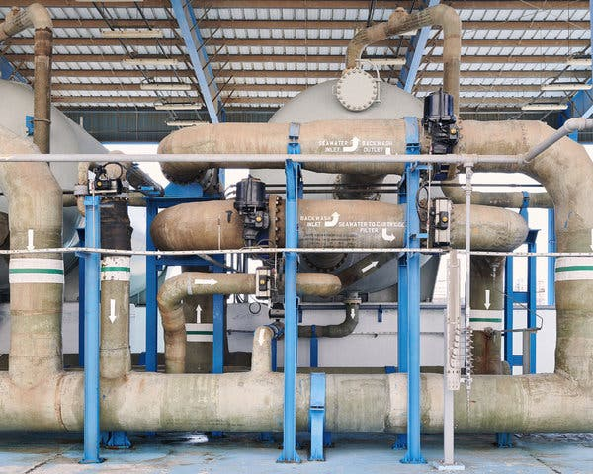
Sand filters at the main Kaust plant. Seawater is pumped through these pipes into the large sand-filled tanks in back, where the sand filters out impurities that could destroy the reverse-osmosis membranes.
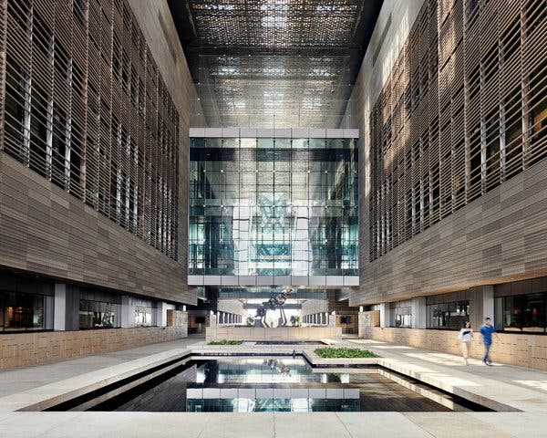
The lobby of the Kaust Physical Science and Engineering Division. The water in the pool is desalinated.
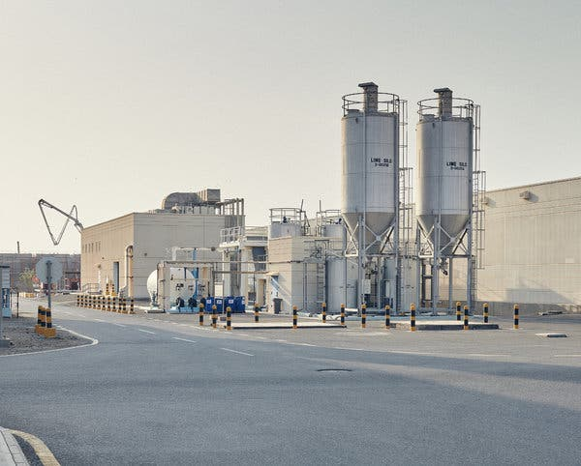
Lime silos outside the Kaust facility holding chemicals used to treat the water after it is desalinated.
Efforts to combine renewable energy and desalination are still in their early stages. One issue is the intermittent nature of most types of renewable power; a desalination plant would still need conventional sources of power at night or when winds are slight. Thomas Altmann, vice president for technology with ACWA Power, which develops, owns and operates desalination and power plants worldwide, said that plants that operate on renewable power 24 hours a day remained a goal. Yet Saudi Arabia and other countries still have many desalination plants that use older thermal technologies that rely completely on fossil fuels. Simply put, these plants boil seawater and condense the resulting steam, which is fresh water.
Thermal plants are usually located next to fossil fuel-burning power plants, and use the excess heat from electricity generation to flash the seawater to vapor. They use tremendous amounts of energy — in 2009, the Saudi minister for water and electricity estimated that one-quarter of all the oil and gas produced in the country was used to generate electricity and produce fresh water.
And gallon for gallon, thermal plants are currently much more expensive to operate than membrane plants. But since some thermal plants have at least a quarter of a century of life left in them, researchers at Kaust are working on ways to make them more efficient. A small pilot plant in one of the research buildings uses solar energy to heat the water directly. The project, run by Muhammad Wakil Shahzad, a research scientist, also broadens the operating temperature range, effectively producing much more fresh water than a conventional thermal design.
Dr. Shahzad and others are designing a scaled-up version of the system for an existing Red Sea desalination plant. “We are at the point where we have to look into out-of-the-box solutions to achieve sustainable water production for future supplies,” he said.
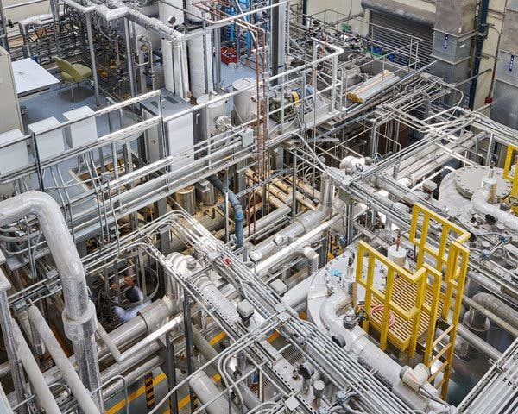
The small pilot plant, which uses solar energy to heat the water for desalination
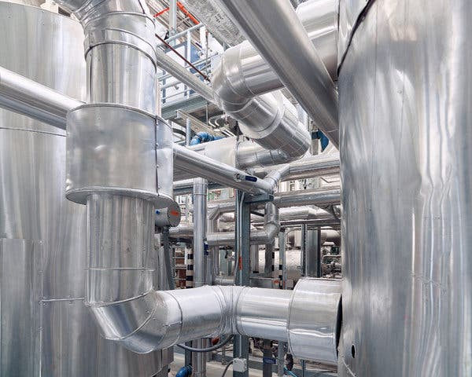
A solar-powered pilot desalination project facility at Kaust.
The Kaust desalination plant’s parking lot. Cooling towers in the back, too, use desalinated water.
Regardless of the method used, all plants produce concentrated brine as a waste product. Dr. Qadir of United Nations University was an author of a recent study showing that brine volumes are greater than most industry estimates — on average, a gallon and a half for every gallon of fresh water produced.
The most widespread current practice is to pump the brine back into the sea. But the extremely salty water can harm seagrasses and fish larvae, and can create oxygen-deprived layers in the water that can harm or kill other marine creatures. The industry argues that if done correctly, locating outlet pipes properly and equipping them with diffusers and other devices to immediately dilute the brine, most, if not all, of those problems can be avoided.
Another approach is to try to do something with the brine other than throwing it away. “We do believe that brine is not just for discharge,” said Nikolay Voutchkov, a technical adviser to the Saline Water Conversion Corp., a government corporation that is the largest producer of desalinated water in the world, responsible for three-fourths of Saudi Arabia’s production. “That’s what we do with it today. But it is actually a very valuable source of minerals.”
At the company’s research institute on the Persian Gulf coast, scientists are studying ways to extract some of those minerals. Obvious targets are calcium and magnesium, which occur naturally in seawater and remain in the brine through the desalination process. Yet for health reasons and to reduce corrosion in distribution pipes, the minerals must be added back to the desalinated water. The current way to do this is by buying them elsewhere. But why not harvest the calcium and magnesium from the brine instead? “Have the chemicals needed for remineralization of the water extracted from the water itself,” Mr. Voutchkov said. “That’s our goal.”

