Cholera in the Middle East and North Africa
Karen Wellner, Biology, Chandler-Gilbert Community College

Earlier in the Bio 205 (Introductory Microbiology) course, my students were introduced to Vibrio cholera, the causative agent of cholera. The pathogenicity, laboratory diagnosis, vaccinology, and importance of John Snow’s epidemiological work with cholera are presented. In textbooks, the story of cholera usually ends with Snow’s work, as if all one had to do was eliminate contaminated water and the problem of cholera is solved.
Rarely is there much discussion of why cholera is still a major disease in Africa and the Middle East. At the end of Snow’s work, I asked students to answer this question: Here we are in 2020 and all kinds of medical technology and infectious disease prevention tools available to us. Why then do we still have so many people around the world dying from infectious disease? While I do not specifically state anything about cholera, this disease is one that many people around the world die from on a daily basis.
Ranked responses (some responders gave more than one answer)
1. Low income/isolated areas/lack of infrastructure: 50
2. organisms mutate or “get stronger”: 21
3. uneducated/unawareness/ignorance: 11
4. lack of proper precautions/personal hygiene: 10
5. not enough research/no cure found yet: 7
6. anti-vaxxers: 6
7. availability of drugs: 7
8. people with poor physiological/immune responses: 5
9. no political will: 5
10. religious beliefs: 4
11. lack of clean water/poor nutrition: 3
12. overpopulation: 2
13. simply hard to control: 2
14. antibiotic resistance: 2
15. lack of imagination: 1

Not only do my students think of the Middle East as an ecologically marginal environment with little improvement to human life, they also have no perception of microbial diseases endemic to the region, or public health campaigns that have been put in place to tackle infectious disease. Simply put, there is an intellectual void in contemporary public health and infectious disease in North Africa and the Middle East.

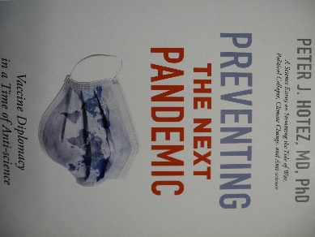
With this in mind and knowing that time is short in a microbiology class, I am working on an assignment that brings together cholera, risk factors, and the seven epidemics of cholera. Each epidemic is viewed through the lens of a reading on a particular Middle Eastern or North African country in which data exists for the cholera outbreak. Each student is given a risk factor sheet, modified from Hotez (2022), shown below. The list will probably be modified even more after students complete their assignment.

Drivers of Cholera Epidemics: A Combination of Risk Factors

CHOLERA

With a risk factor sheet, each student is given one article pertaining to one country and one cholera epidemic time period. There is also a map of the country or city to give the reading more context. From the reading, students identify key risk factors for their particular epidemic. In class, students who were assigned the same reading will work together and compare their risk factor sheets, making adjustments if necessary or adding risk factors not on the risk factor sheet. Group conclusions are compared and a whole class conclusion about cholera is generated; The readings and maps for the assignment are shown in this table:
Epidemic | Duration | Country Targets | Reading | Map
1 | 1817−1826 | African coast  Baghdad  Tehran |  | 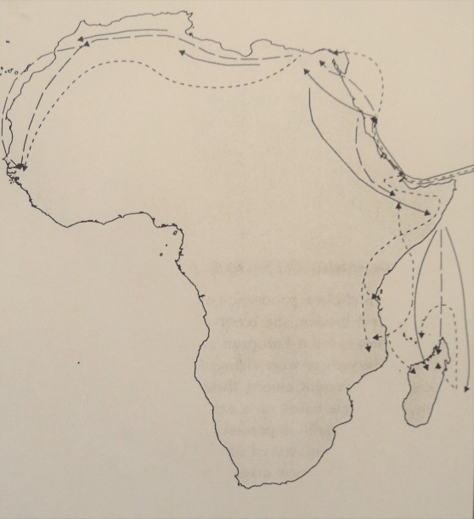
2 | 1828−1836 | Egypt | 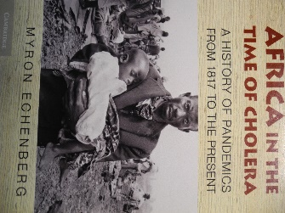  Parts of chapter 1 In Quest of Justice: Islamic Law and Forensic Medicine in Modern Egypt by Khaled Famy and parts of Africa in the Time of Cholera. A History of Pandemics from 1817 to the Present by Myron Echenberg (2011) | 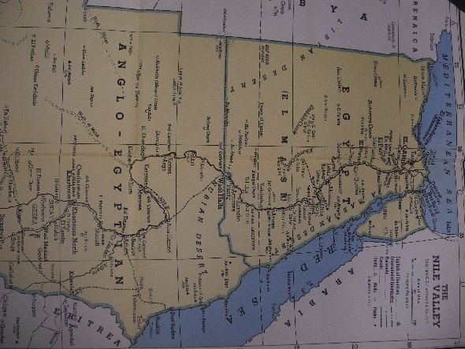
3 | 1839−1861  John Snow’s work | Egypt | Parts of “Cholera, Colonialism, and Pilgrimage: Exploring Global/ Local Exchange in the Central Egyptian Delta, 1848−1907.” By Stephanie Boyle. Journal of World History 26(3) 581-604. 2015. | 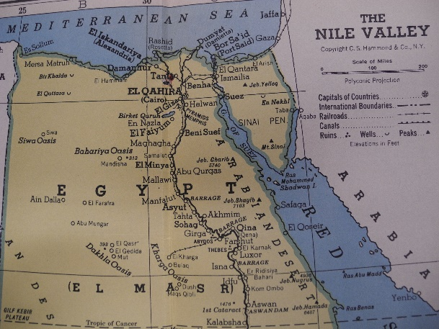
4 | 1863−1879 | Saudi Arabia (Hijaz) | 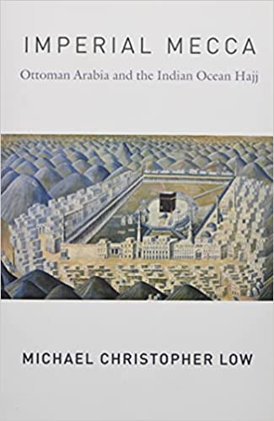  “Microbial Mecca and the Global Crisis of Cholera,” 141-148. In Imperial Mecca. Ottoman Arabia and the Indian Ocean Hajj by Michael Low. 2020. | 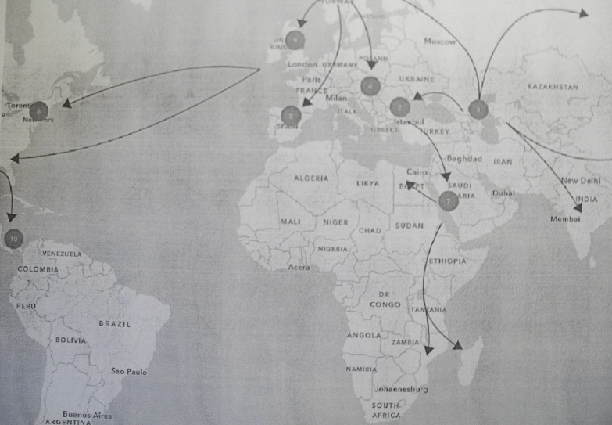
5 | 1881−1896  Koch’s work | Iran | 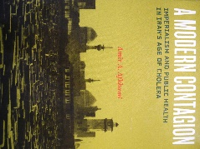  “The 1889-1893 Cholera Epidemic” in, A Modern Contagion. Imperialism and Public Health in Iran’s Age of Cholera by Amir A. Afkhami (2019) and “History of Cholera Outbreaks in Iran during the 19th and 20th Centuries” by M. H. Azizi, Middle East Jour. of Diges-ive Diseases Vol 2(1):51-55. 2010 | 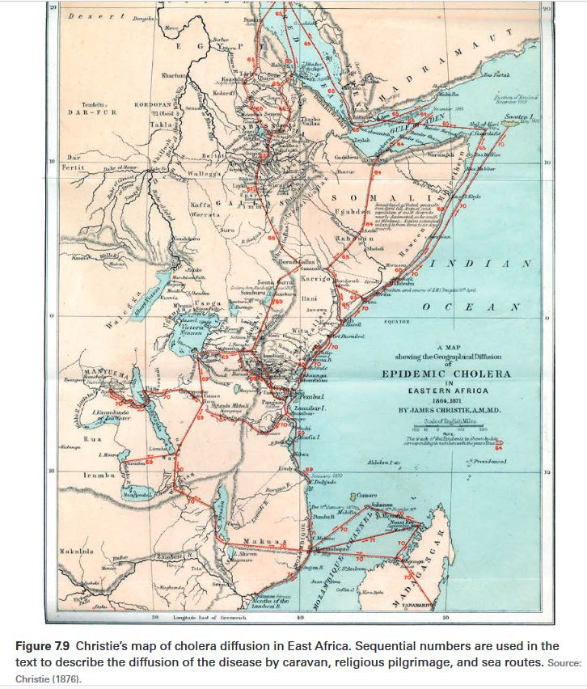
 |  | U.S. Incidence | of Cholera Drops Drastically
6 | 1899−1923 | Iraq | Ungovernable Life. Mandatory Medi- cine and Statecraft in Iraq by Omar Dewachi (2017) | 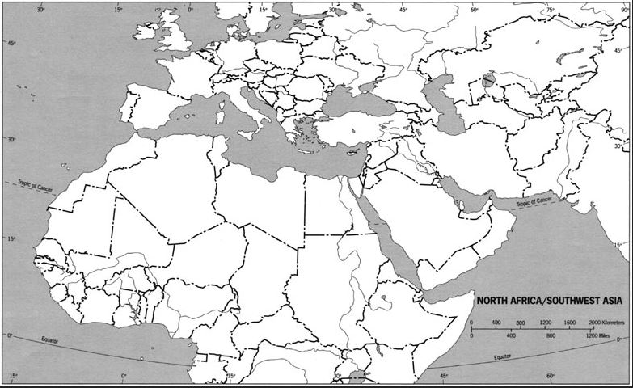
7 | 1961−2022 | Yemen | “It’s a Slow Death: The World’s Worst Humanitarian Crisis.” NYT. 23, 2017 and “Mystery of Yemen Cholera Epidemic Solved.” Science Daily Jan. 2, 2019 | 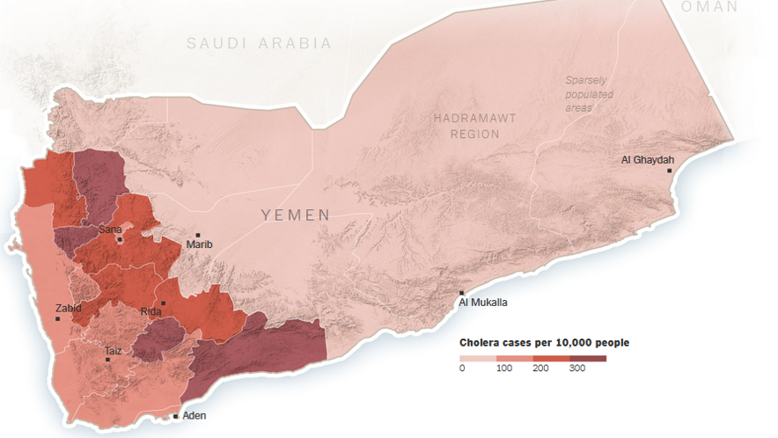

I hope to help students see why the United States has become relatively cholera-free since the Civil War. Since then, with adoption of the Germ Theory of Disease, Federal and State Public Health systems, and engineering focused on clean water and sanitation has resulted in a tremendous drop and maintained drop in cholera. Since medicine and microbiology are so focused on what has happened in the U.S. and Europe, it is not a surprise that students think cholera is “no big deal”.
In the student readings, some of the countries the readings examine also took action just like the United States. But those countries have suffered from Civil Wars and ineffective public health systems which has disrupted the infrastructure and health care systems. The United States has not had a war on American soil since 1865. It’s not that Vibrio cholera has disappeared in the United States; it’s just that we have had far fewer risk factors that we must contend with.
After completing the assignment, we returned to the questionnaire results to see how students felt about their answers once investigating cholera epidemics and to get a better explanation of why the U.S. remained cholera free since 1866. The classes agreed that epidemics are described differently, depending on who is telling the story and that epidemics like cholera and COVID-19 are more complex than complicated.

